Using and reporting on surveys

Surveys
Schools or teachers frequently use surveys as a basis for accessing, interpreting, and analysing the opinions/perspectives of young people.

A well-constructed and administered student survey allows large numbers of young people to voice their insights, opinions, needs and desires about what would improve their experience in school in an anonymous, safe and efficient manner. Surveys can also be used in the classroom by young people to give feedback to teachers about their experience of learning including suggestions to help young people to learn better in class.

Surveys can be used
- at the beginning of a process or initiative, to gain greater understanding of the main issues involved. These insights can be further unpacked with the young people in focus/class groups.
- following a focus group conversation. The insights from these conversations can be used to agree/design the survey to access the voices of a greater number of young people
- at end a project/process to support evaluation.

Engaging young people
Young people are more likely to take surveys seriously when they are convinced that what they say will be acknowledged through genuine discussion, if not visible change. At a most basic level, data gathered from surveys can inform the relevant planning or decision-making processes. However, young people are much more than data sources. Ideally schools should plan to discuss the findings with young people and take their ideas and suggestions on board in planning next steps. School management, teachers, and young people can work in partnership to achieve these outcomes.

Teachers using survey outcomes
Teachers can engage with the survey findings in different ways:
- taking on board the findings of the survey in reflecting on the implications for one’s own teaching practice
- teasing out the findings with colleagues in their subject and/or across subject departments
- unpacking the findings with a group of young people drawn from a number of classes. This approach can include teachers also and can be a powerful opportunity to share power in the decision making.
- unpacking the findings with one’s classes and planning next steps to support learning.

Beginning the process
At the outset, it is important to plan for the following elements in the design process:
- Deciding on the purpose and audience for the survey
- Designing the survey
- Trialling the questions
- Recording responses
- Collating the findings
- Examining findings
- Prioritising what to share with key stakeholders
- Preparing and presenting findings.

Designing a survey
Surveys are easy to design. Using Google forms is one way of doing it. In Appendix 1 there is a sample survey which was used in the design of this toolkit. It is useful to trial the survey to ensure it is fit for purpose. In introducing the survey, clearly state
- the purpose of the survey
- the audience(s) for the findings
- how feedback on the results of the survey will be shared with participants
- what influence the findings are likely to have and how the participants will be informed about this.

Tips
- Keep the survey short and pilot the questions to ensure clarity and accessibility.
- Plan to provide timely feedback on findings to participants.
- Plan for any follow up sessions to further unpack the findings.

Participation with purpose
Participation with purpose means that when young people are involved in decision-making, their views or needs are listened to, taken seriously and given due weight with the possibility of leading to an outcome or change. It is important not to get stuck in the process of ‘doing’ participation, but to ensure that the participation of young people in decision-making has a purpose. The purpose should lead to an outcome, which can be about either young people having an impact on issues that affect them collectively or issues that affect the individual young person.

Participation Prompts; Planning and Review
When planning or reviewing a young people’s voice initiative consider using these prompts to check for consistency with Lundy’s model of participation. It is not expected that every box will be ticked for every survey.
SPACE  Provide a safe and inclusive space for young people to form and express their views | AUDIENCE  Ensure that young people’s views are communicated to someone with the responsibility to listen
  Are the young people affected by this issue involved? | ☐
  Are steps taken to ensure that the process is inclusive? | ☐
  Do the young people feel safe to express themselves freely in the space? | ☐
  Are the young people who are interested in the issue involved? | ☐
  Are the young people be involved from the start? | ☐
  Are the right decision-makers involved, i.e. those responsible for decision making on this issue? | ☐
  Have these decision makers committed to taking the young people’s feedback seriously? | ☐
  Is there a process in place to ensure that the young people’s voices are given due weight and consideration? | ☐
  Are there plans to have the young people have a role in presenting their views | ☐

VOICE  Provide appropriate information and facilitate the young people to express their views | INFLUENCE  Ensure that young people’s views are taken seriously and acted upon, where appropriate
  Do the young people have the information they need to form a view? | ☐
  Are the young people be given a range of options on how to express themselves? | ☐
  Do the young people know to whom their views will be communicated? | ☐
  Does the process include opportunities for young people to identify issues that they want to discuss? | ☐
  Do the young people know they have a choice about their participation? | ☐
  Are the young people clear about the scope of their influence, (opportunities and limitations)? | ☐
  Will young people be given feedback explaining the reasons for decisions taken? | ☐
  Will the young people be given an easily accessible summary of their views? | ☐
  Do the young people know who the key decision makers involved are? | ☐
Participation prompts; planning and review

Collaborating with colleagues in the use of surveys.

Step 1: Initiating the survey
- Identify the group of colleagues interested in using student surveys to inform issue(s) under consideration.
- Consider using the insights of young people in co-designing survey tools and planning for further action.
- Invite more colleagues to hear about this work, e.g. who is involved, the aim of the survey and how it will be managed
- Include more teachers in the process if they are interested.

Step 2 Question design (sample questions in Appendix 2)
- Agree with colleagues how young people will be involved in the question design
- When reviewing the questions with colleagues (and young people!) share the purpose behind each question, encourage questions and sharing of thoughts/concerns.
- Emphasise that questions provide an opportunity to understand more about young people’ experience of learning and school and that surveys are not an occasion for criticism of teachers or management.
- Provide opportunities for those not directly involved in the design process (teachers, parents, school management) to voice any concerns that they may have.

Step 3 Administering the survey
Explain to all participants
- the purpose of the survey
- the importance of completing it carefully and completely
- the option to complete it anonymously
- the option not to complete it
- how feedback will be given and acted upon.

Step 4 Processing, interpreting, reporting/presenting
- Collate the findings and summarize the key points
- Present findings in a form appropriate for the different audience(s). Formats might include slide presentations, graphics, visuals, handouts, posters sessions.
- Design the presentation to encourage dialogue
- What surprised you?
- What pleased you?
- What unsettled you?
- What further opportunities does this feedback provide?
- Are there challenges arising from the feedback?
- What might be the next steps?
- It is important to provide a non-judgemental feedback that focuses clearly on the findings
- Agree who will make the presentation – teacher, student, combination?
- Plan to act on the feedback ensuring that a manageable amount of change is undertaken.

Step 5 Getting school-wide buy in
- Share your experiences with other colleagues, school management – what worked, what were the challenges and where to next.
- Share survey tools that you may have found useful and invite other staff to trial them.

Check out one teacher’s experience of using a student survey to inform his planning for learning and teacher here.

Step 5 Using student focus groups to unpack survey findings.
Student surveys will provide lots of interesting and valuable feedback. They will also throw up many questions and surprises. It is useful to consider organising one or more focus groups with young people to better understand the feedback coming from surveys. See ‘Organising, running and reporting on focus groups’ tool to support this work.

Reflection on student voice process
Having completed the survey and followed up on the findings there is an opportunity to reflect on the experience with colleagues and young people.

Some questions for young people:
- How do you know that your voice has been heard and acted upon having completed this survey?
- Which worked well in this process?
- What would have made the experience better and more worthwhile?
- If the school/teacher wanted to repeat a similar consultation, what advice would you give?
- Show the gaps - Are there particular areas where young people could have a greater ‘say’ but currently do not?
- What advice would you give to teachers involved in Student Voice in our school?

For teachers:
What worked well with this survey?
What would you do differently if you were involved in a similar process in the future?
What impact has this initiative had on your
- teaching practice?
- relationship with young people?
- relationship with colleagues?
What piece of advice would you give to a fellow teacher about to embark on a similar process?

For teachers and young people:
- How could young people be encouraged to take greater leadership roles in similar initiatives?
- Spotlight equity issues - In this consultation, were there some young people who get fewer opportunities than others? If so, how might the shortcomings in this area have been addressed?

Appendix 1
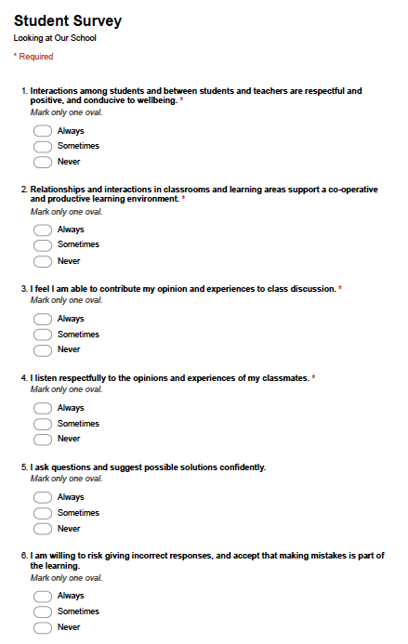

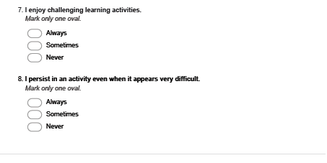

Appendix 2

Sample questions:

- Our teacher encourages us to take risks in our thinking.
  - Rarely
  - Sometimes
  - Usually
  - Always

- I feel I am able to contribute my opinion and experiences to class discussion.
  - Rarely
  - Always
  - Sometimes
  - Never

- I receive regular helpful feedback from my teachers about how I can improve my learning in different subjects
  - Rarely
  - Always
  - Sometimes
  - Never

- I believe I am doing well in school overall
  - Strongly agree
  - Agree
  - Not sure
  - Disagree
  - Strongly

- Please add a comment here for your answer to question 4, if you wish.

Insert reference for DCYA National Implementation Framework for Child Participation

