Planning surveys

Want to change or improve something in your school? Keen to put a new initiative in place?

As part of your initiative, why not consider using a survey? Surveys work well when you want to hear the insights, opinions, needs and desires of a group of young people and/or other stakeholders. Surveys can also help others to learn about the initiative you are undertaking.

Surveys can be used

- at the beginning of an initiative, to gain a greater understanding of the main issues involved. These insights can be further unpacked with the students, teachers, school management, parents in focus groups.
- following a focus group conversation about the initiative. The insights from these conversations can be used to design the survey
- at the end of the initiative to support evaluation.

Once you decide to use a survey, it is important to discuss your ideas with school management and/or a co-operating teacher. With their support, you can agree when and how the survey can be carried out. You can also agree who the feedback from the survey will be shared with and how the feedback will influence the next steps in your initiative.

Designing a survey
Surveys are easy to design but they do take time. Using Google forms is one way of doing it. In Appendix 1 there is a sample survey which was used in the design of this toolkit. It is useful to trial the survey to ensure it is fit for purpose.

In introducing the survey, clearly state
- the purpose of the survey
- the audience(s) for the findings, i.e. who will be listening to the feedback?
- how the findings will be used to influence the initiative been undertaken.

Tips
- Keep the survey short and pilot the questions to ensure clarity and accessibility.
- Include opportunities for participants in the survey to bring up their own ideas and opinions
- Consider asking other stakeholders, e.g. teachers, parents, to complete the same survey
- Plan to provide timely feedback on findings to all those who complete the survey.

When planning or reviewing a young people’s voice initiative consider using Participation prompts; planning and review to check for consistency with Lundy’s model of participation.

SPACE  Provide a safe and inclusive space for young people to express their views | AUDIENCE  Ensure that young people’s views are communicated to someone with the responsibility to listen
  Are the young people affected by this issue involved? | ☐
  Are steps taken to ensure that the process is inclusive? | ☐
  Do the young people feel safe to express themselves freely in the space? | ☐
  Are the young people who are interested in the issue involved? | ☐
  Are the young people be involved from the start? | ☐
  Are the right decision-makers involved, i.e. those responsible for decision making on this issue? | ☐
  Have these decision makers committed to taking the young people’s feedback seriously? | ☐
  Is there a process in place to ensure that the young people’s voices are given due weight and consideration? | ☐
  Are there plans to have the young people have a role in presenting their views | ☐
Participation prompts; planning and review

VOICE  Provide appropriate information and facilitate the young people to form and express their views | INFLUENCE  Ensure that young people’s views are taken seriously and acted upon, where appropriate
  Do the young people have the information they need to form a view? | ☐
  Are the young people be given a range of options on how to express themselves? | ☐
  Do the young people know to whom their views will be communicated? | ☐
  Does the process include opportunities for young people to identify issues that they want to discuss? | ☐
  Do the young people know they have a choice about their participation? | ☐
  Are the young people clear about the scope of their influence, (opportunities and limitations)? | ☐
  Will young people be given feedback explaining the reasons for decisions taken? | ☐
  Will the young people be given an easily accessible summary of their views? | ☐
  Do the young people know who the key decision makers involved are? | ☐

Collating your findings
- Once the survey has been completed, the feedback can be collated easily using the Goggle Survey Tool.
- Summarize the key points of feedback from participants.
- Consider comparing responses from different groups within the survey.
- Present findings in a form appropriate to your audience(s). Formats might include slide presentations, graphics, visuals, handouts, posters sessions for audiences such as…
- student assemblies
- class group(s)
- staff meeting
- Board of Management
- Parents’ Council.

Preparing and making the presentation of findings
Prepare a sharp, short focused presentation
- Who will make the presentation – student, teacher, combination?
- Keep the presentation short (5– 7 min).
- Highlight the most significant finding from your/your group’s perspective.

Design the presentation to encourage dialogue by using prompts such as
- What surprised you?
- What pleased you?
- What unsettled you?
- What further opportunities does this feedback provide?
- Are there challenges arising from the feedback?
- What might be the next steps?

Appendix 1
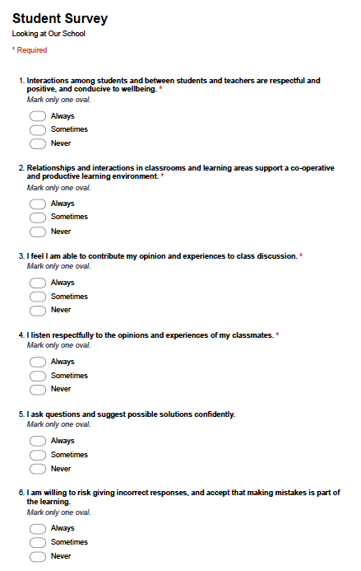

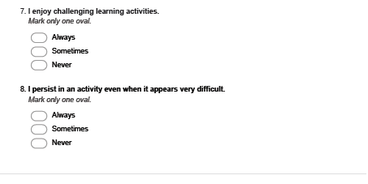

Adapted from PILOT – activating student voice – accelerating improvement, Government of South Australia, Department of Education and Child Development (https://www.acleadersresource.sa.edu.au/features/pilot/DECD_TfEL%20PILOT_Student%20voice%20audit_web.pdf)

