Key skills and collaborating with colleagues

Young people’s confidence is built overtime though multiple opportunities to be actively involved in their learning, make decisions, set goals, problem solve and reflect on their learning.
When young people’s engagement matters day-to-day, they are more likely to be well placed to contribute to conversations about their learning and decision-making at whole school level, e.g. School Self Evaluation (SSE). Actively involving young people in their learning as they develop the key skills provides opportunities for young people to build their confidence in voicing their ideas and opinions.

Collaboration with colleague(s) in planning for the development of Key Skills
- With a colleague(s), agree to focus on one key skill, in particular, in your classroom for the coming weeks.
- Review the relevant NCCA Key Skill Tool Kit and JCT Classroom Strategies
- Select a small number of classroom strategies to try in your classroom. Share ideas on how these strategies could be used or adapted within your subjects
- Agree how best to maximise young people’s voice when using these classroom strategies
- Outline with your students what is planned and agree to take on board their feedback to inform next steps
- Consider these strategies through the lens of Lundy participation model
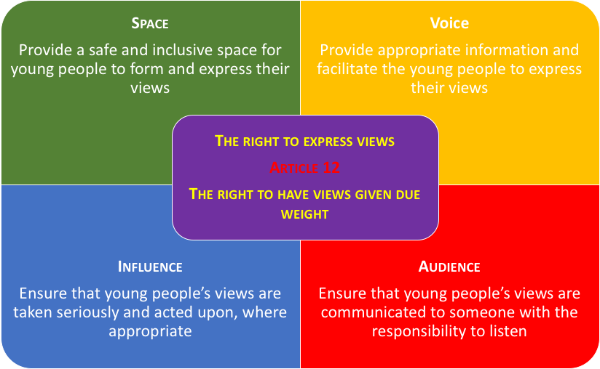
- Agree a timeframe for this process and consider inviting a colleague to be a critical friend in this work. The Teacher Peer Observation tool could be used in this context, (Appendix 1).
Appendix 1:

Teacher peer observation tool

Are you collaborating with colleagues to develop young people’s ‘participation with purpose’ in your classroom?

Would you consider observing each other’s teaching practice and reflecting together on what appears to be working well and how it might be improved?

This observation template is designed to support teachers who are working together to build young people’s ‘participation with purpose’ in their classroom. Teachers can use the template in their observation of a colleague’s teaching. The material arising from this observation is then used to support a feedback/reflection conversation with their colleague following the lesson observation.

Step 1.
During the lesson, your colleague observes the lesson in order to provide constructive feedback and act as a critical friend in a joint reflection after the lesson.
Step 2.
Following the lesson, your colleague will invite you to reflect on what went well and what area(s) you think you would like to improve. This conversation should be based on the areas included in the observation template below.
Step 3.
Your colleague will then give their feedback about the lesson using the observation tool below to support the conversation.
Step 4:
Consider together next steps because in observing another’s practice, there is often learning for both the observing teacher and the teacher being observed.

Appendix 1: Teacher peer observation tool
Student Voice and Agency in the Classroom
Teacher: _________________________ Date: _____________________
Co-operating colleague: ______________________
STUDENT VOICE | Indicate on a 1-5 scale where 1 is Never and 5 is Always |  |  |  |  | EVIDENCE
 | 1 | 2 | 3 | 4 | 5 | EVIDENCE
Students’ views are valued in this classroom
The needs of all students are met.
Students take ownership of their learning in different ways
Students have opportunities to reflect on and talk about their learning.
Students are encouraged to take responsibility for their learning
Students are encouraged to take responsibility for their behaviour
Relationships between students and teachers are open and trustful.
Students are engaged in self and/or peer assessment
Teacher invites and listens to students’ feedback
Students are actively involved in the design of learning experiences and assessment
Students sometimes take on teaching roles
Students work with one another – listen to one another and respect different views.
Students are motivated and engaged in learning.

Adapted from a resource developed by the National Education Institute Slovenia (Zavod Republike Slovenije za šolstvo). Research Project Material of NEI Slovenia – Formative Assessment (2016-2017).

